**Synopsis/Proof of concept**

**Idea/Approach of details**

**Abstract:**

For lawyers it is very difficult task to maintain all the files of all the cases manually, to manage all the information about client , important records etc. To maintain this data proper system is required. Client has to make many inquiries before they hire the lawyer for their case. Many factors have to be kept in mind such as Communication between lawyer and client, Security of data, Complete details of each cases, Reminder of important dates, Cases records for further use, Maintaining a Rule book and Different forms, Complete detailed portfolio of lawyers for hiring lawyers, etc. Moreover, our aim is to develop a system that could prove to be useful for any lawyer and client for easily maintaining all the records of cases and other informations.

**Literature review**

🡪 This section throws light on some of the issues that are faced in current systems.

🡪 We ourselves visited lawyers and some of the known websites like kanoon.com, indiankanoon.com, lawrato.com,lawzgrid.com and noticed their shortcomings as per user’s views.

For example:

* Most of the websites does not provide chat mechanism. Thus, users may not be able easily talk with the lawyer about their case.
* Level of complexity is high so many users and lawyers may avoid to use it.
* These sites don’t have Rule book in their System and User have to search for different types of forms for different uses.
* Most of the websites are only work for hiring lawyers, they don’t provide portal for lawyers for manual process.
* If lawyer wants to find reference of older case they have to find manually, it is very time consuming and lengthy process.

**Proposed System/ What would be your approach to solve the problem:**

* Website that has been developed to help the Lawyers to keep their data of all the cases and data of their clients at one place rather than keep the manual files.
* Our primary concern is to develop an website that provides a central platform that gathers number of lawyers which makes it easy for the users(who need help from lawyers) to take an legal advice for their cases.
* Lawyer can upload all the necessary documents on the portal and make notes of important things.
* Lawyer can set reminders of the important dates like, next hearing date etc.
* Client will also get notification about hearing dates.
* Client can find important forms which are necessary for the case.
* Lawyer and client can communicate through chat mechanism.
* Client can also get the related information of case uploaded by Lawyer.
* Lawyer can refer the Rule book which has brief about any rule.
* Lawyer can also search for older case for further reference.

**Challenges in implementing our system:**

* Keep website as simple as possible so as to ease lawyer’s task of managing his cases and client details.
* Lawyers can have many clients many cases, many previous cases records. So, database for maintaining every details can became very large and complex.
* Notify Lawyer as well as Client about further cases and case details.
* To make a Rule book we have to take care of very small details one single mistake can cause big troubles.
* There is a form gallery, In which you can find any work relevant forms. So we have to put all forms.
* For hiring a lawyer , user can search lawyer by different categories and can search their portfolio. So we have to make trusted and verified portfolio of lawyers.

### Flowchart:

**1.Client Side:**

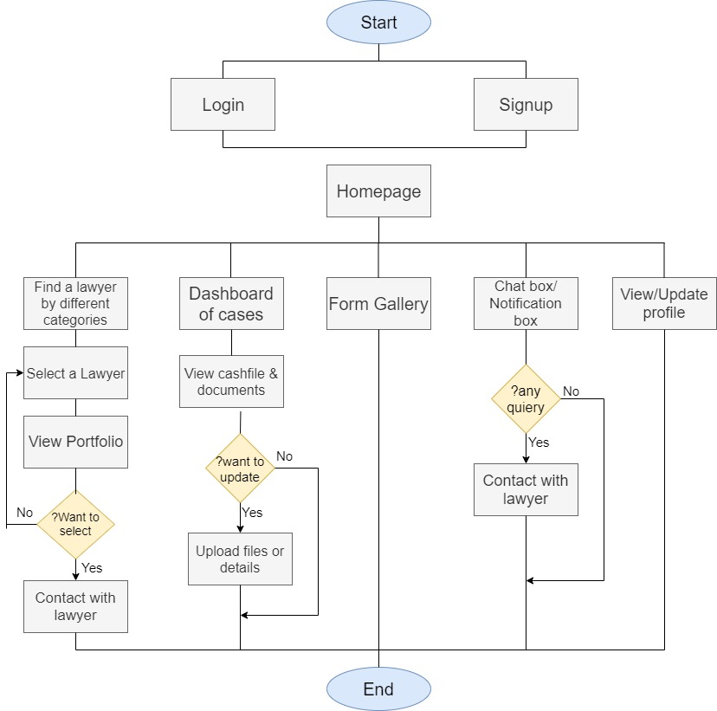

**2.Lawyer Side:**

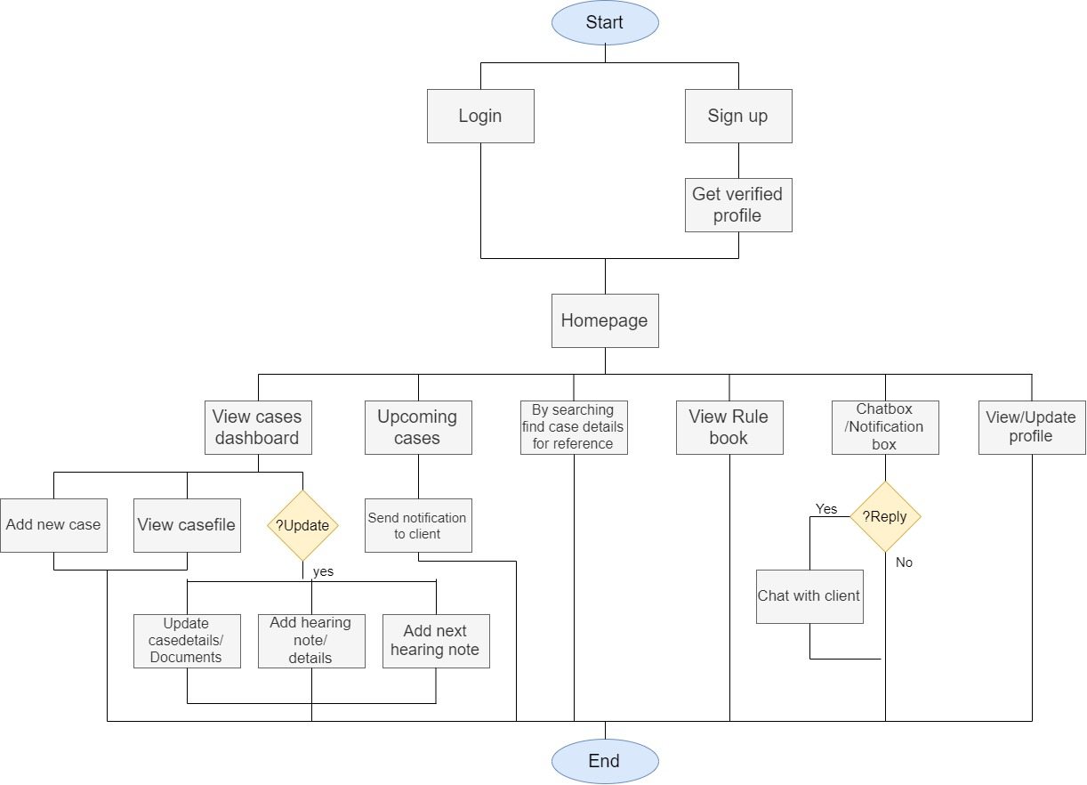

**3.Admin :**

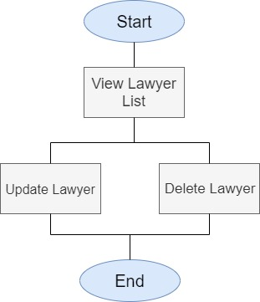

**Tools/Technologies to be used to solve the problem:**

**# Main technology (Coding):**

**🡪 Front End:** HTML, CSS, Java Script (for user and admin website)

**🡪 Back End:** PHP and MySql (for user and admin website)

**🡪 Minimum Hardware Requirements:**

* Operating System: Windows XP or Android OS
* Web browser: All available
* Active Internet Connection: 512 kbps
* RAM: 2048 MB (2 GB ) or more

**Possible outcome of the work:**

🡪 Client can search lawyer by different categories and see their work and profile.

🡪 All the records were made online so that file handling will be easy for lawyers.

🡪 There is a rulebook so lawyer can easily find information about that law by searching.

🡪 There is Form gallery , so user can easily find any form which they needed and fill that from and get printed.

🡪 Lawyer will be able to store information about every case which is handle by him/her and meanwhile client will also get notify about next hearing details and current status of case.

🡪 There is chat mechanism for communication between client and lawyer.

**Prototype:**

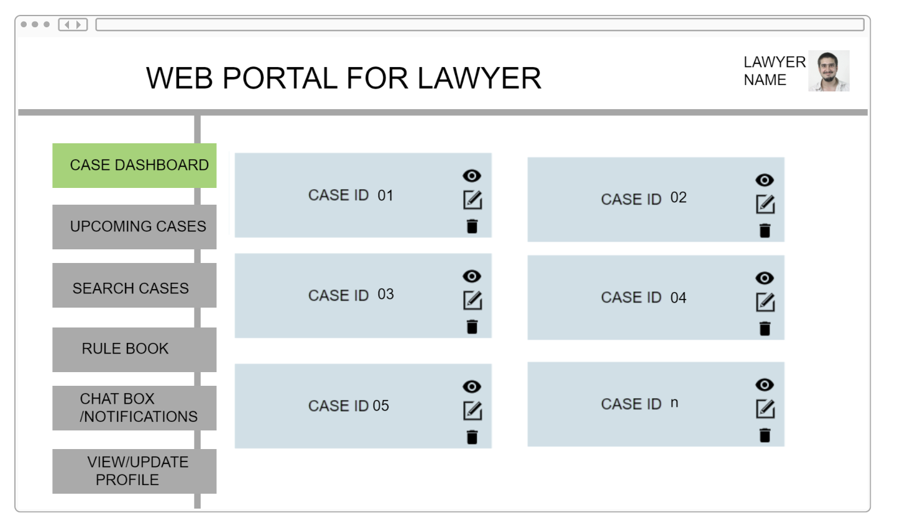

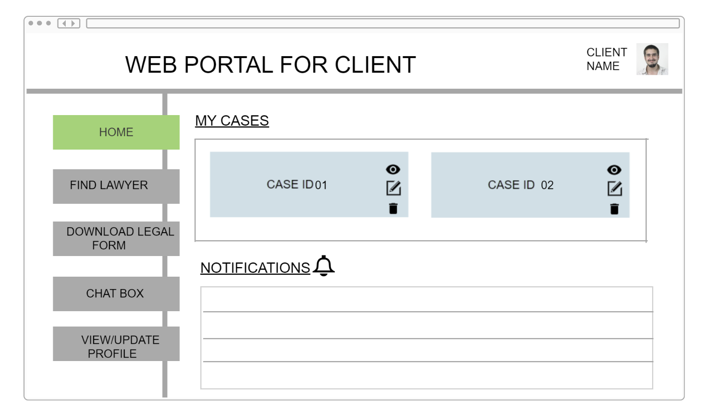

**Report/Work done till date:**

🡪 First of all we have discussed about this problem in our group and then we went to our mentor and discussed problem and he gave us some solution and guideline.

🡪 We visited lawyers .We discussed with them about this problem and tried to better understand the problem, took some suggestions from them that how can we overcome this problem and some more features that can be useful to them. We have also visited several different sites which are available so that we can get the better idea how can we make our system more useful.

🡪 We have discussed proposed system flowchart, what tools and technologies we are going to use and how our website will work.